 | 8.1.7 Editors - Image Editor - Header - Mask menu
Table of content
Image Editor - Mask menu 2
Delete 2
Duplicate 2
Toggle Cyclic 2
Switch Direction 2
Recalc Normals 2
Set Handle Type 3
Last Operator Set Handle Type 3
Type 3
Clear Parent 3
Make Parent 3
Copy Splines 3
Paste Splines 3
Show/Hide 3
Show/Hide Faces 3
Show Hidden 3
Hide Selected 3
Hide Unselected 3
Transform 4
Translate 4
Last Operator Move 4
Values 4
Axis Ortho 4
Orientation 4
Proportional Editing 4
Proportional Editing Falloff 4
Proportional size 4
Connected 4
Projected ( 2D) 4
Rotate 5
Last Operator Rotate 5
Angle 5
Axis 5
Orientation 5
Proportional Editing 5
Proportional Editing Falloff 5
Proportional size 5
Connected 5
Projected ( 2D) 5
Scale 5
Last Operator Resize 5
Scale X Y Z 5
Orientation 6
Proportional Editing 6
Proportional Editing Falloff 6
Proportional size 6
Connected 6
Projected ( 2D) 6
Scale Feather 6
Last Operator Transform 6
Values 6
Axis 7
Orientation 7
Proportional Editing 7
Proportional Editing Falloff 7
Proportional size 7
Connected 7
Projected ( 2D) 7
Clear Feather Weight 7
Animation 7
Insert Shape Key 7
Clear Shape Key 7
Feather Reset Animation 8
Re-Key Points of Selected Shapes 8

Image Editor - Mask menu

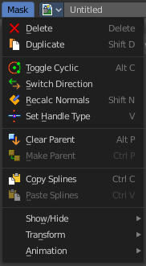
This menu appears when you are in Mask mode. It contains further functionality to modify the masking spline curves.

Delete
Deletes the selected spline(s) or spline points.

Duplicate
Deletes the selected spline(s) or spline points.

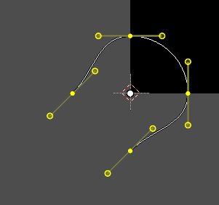
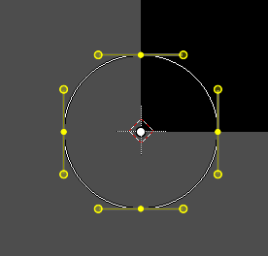
Toggle Cyclic
Closes or opens the spline.

Switch Direction
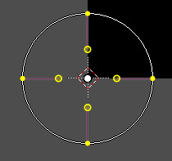
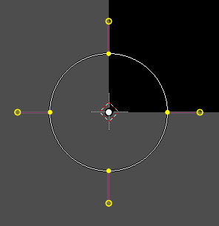
A curve has a start point and a end point. Here you can switch them. The end point becomes the starting point and vice versa. As a consequence the handler can switch their location too. With handle type aligned single they can appear outside or inside of the circle.

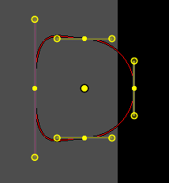
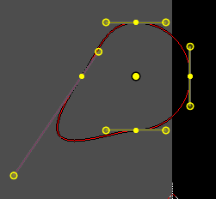
Recalc Normals
Recalculating the normals smoothens out the curve, and realigns the handlers. A square shape with handle type aligned would become round.

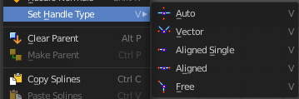
Set Handle Type
Opens a sub menu where you can choose different handle types.

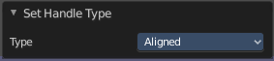
Last Operator Set Handle Type

Type
Choose the handle type again.

Clear Parent
Clears the parent relationship.

Make Parent
Parents the selected spline points. Mask splines can be parented to motion tracker markers.

Copy Splines
Copy the selected spline(s) or spline points.

Paste Splines
Pastes the copied spline(s) or spline points.

Show/Hide

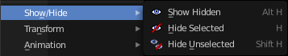
Show/Hide Faces
This is a sub menu where you can show or hide the selection.

Show Hidden
Makes hidden splines visible again.

Hide Selected
Hides the selected spline(s).

Hide Unselected
Hides the not selected spline(s). The selected spline(s) stays visible.

Transform
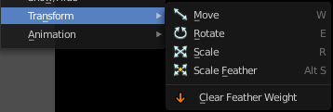
This is a sub menu with some transform menu items. This menu items are hotkey tools!

Translate
Move the selection.

Last Operator Move

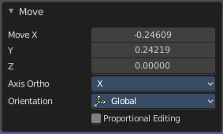
Values
Adjust the move amount.
X, Y and Z defines the position.

Axis Ortho
Along which axis to move

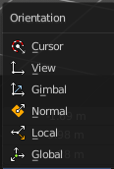
Orientation
Orientation is a drop-down box where you can choose the type of orientation for the transform action.

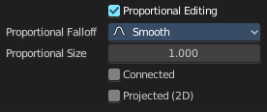
Proportional Editing
Proportional Editing is a drop-down box where you can choose to use proportional editing. When you choose one of the active methods then the neighbor geometry gets influenced too in a proportional way.

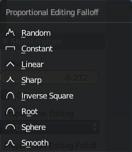
Proportional Editing Falloff
Proportional Editing Falloff is a drop-down box where you can choose a method for the falloff for the proportional editing.

Proportional size
Proportional size is a edit box where you can adjust the strength of the Proportional falloff.

Connected
Just edit geometry that is directly connected with the current selection. 4 Bforartists 2 Reference Manual - 7.1.4 Editors - 3D View - Header - Navigation Menu

Projected ( 2D)
Edit geometry that is in 2d space aligned with the current selection. This one goes from the current view in depth direction.

Rotate
Rotate the selection.

Last Operator Rotate

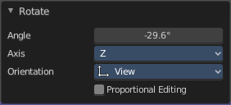
Angle
Adjust the angle.

Axis
Along which axis to rotate

Orientation
Orientation is a drop-down box to choose the type of orientation for the transform action.

Proportional Editing
Proportional Editing is a drop-down box where you can choose to use proportional editing. When you choose one of the active methods then the neighbor geometry gets influenced too in a proportional way.

Proportional Editing Falloff
Proportional Editing Falloff is a drop-down box where you can choose a method for the falloff for the proportional editing.

Proportional size
Proportional size is a edit box to adjust the strength of the Proportional falloff.

Connected
Just edit geometry that is directly connected with the current selection. 4 Bforartists 2 Reference Manual - 7.1.4 Editors - 3D View - Header - Navigation Menu

Projected ( 2D)
Edit geometry that is in 2d space aligned with the current selection. This one goes from the current view in depth direction.

Scale
Scale the selection.

Last Operator Resize

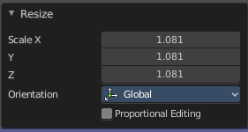
Scale X Y Z
Adjust the scaling.

Orientation
Orientation is a drop-down box to choose the type of orientation for the transform action.

Proportional Editing
Proportional Editing is a drop-down box where you can choose to use proportional editing. When you choose one of the active methods then the neighbor geometry gets influenced too in a proportional way.

Proportional Editing Falloff
Proportional Editing Falloff is a drop-down box where you can choose a method for the falloff for the proportional editing.

Proportional size
Proportional size is a edit box to adjust the strength of the Proportional falloff.

Connected
Just edit geometry that is directly connected with the current selection. 4 Bforartists 2 Reference Manual - 7.1.4 Editors - 3D View - Header - Navigation Menu

Projected ( 2D)
Edit geometry that is in 2d space aligned with the current selection. This one goes from the current view in depth direction.

Scale Feather
Scale feather weight for the selected points.
The curve type that is used to create mask splines is almost a Bezier curve. But it has some differences. Smooth edges of the mask are defined by feathering. The curve needed to support feathering in a way that stuck to the curve as you edited it, for ease of editing an animation. These are called S-Curves.
Besides the handles, every control point also has points that define the feather between the current point and the next point on the spline. Each feather point is stored in UV space, where U means position across spline segment, and V means distance between main spline and feather points.

Last Operator Transform

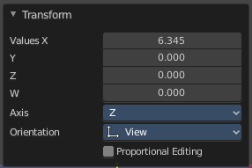
Values
Adjust the scale amount.
X, Y and Z defines the position. W defines the rotation.

Axis
Around which axis to rotate. X, Y or Z.

Orientation
Orientation is a drop-down box to choose the type of orientation for the transform action.

Proportional Editing
Proportional Editing is a drop-down box where you can choose to use proportional editing. When you choose one of the active methods then the neighbor geometry gets influenced too in a proportional way.

Proportional Editing Falloff
Proportional Editing Falloff is a drop-down box where you can choose a method for the falloff for the proportional editing.

Proportional size
Proportional size is a edit box to adjust the strength of the Proportional falloff.

Connected
Just edit geometry that is directly connected with the current selection. 4 Bforartists 2 Reference Manual - 7.1.4 Editors - 3D View - Header - Navigation Menu

Projected ( 2D)
Edit geometry that is in 2d space aligned with the current selection. This one goes from the current view in depth direction.

Clear Feather Weight
Resets the scale to its original dimensions.

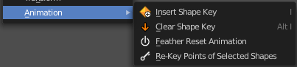
Animation
Masks can be animated.

Insert Shape Key
Inserts a shape key for the currently selected curve points

Clear Shape Key
Removes the shape keys for the currently selected curve points at the current frame.

Feather Reset Animation
Resets the feather weight on all selected curve points at the current frame.

Re-Key Points of Selected Shapes
Recalculate animation data for the currently selected curve points for frames that are selected in the dope sheet.

